Effort Estimation
Effort estimation is the process of predicting the amount of work (normally expressed in person-months), the cost, and the duration required to develop a software product. It is performed when information is incomplete and is refined iteratively as the project progresses.
Why it is difficult
- Requirements are often incomplete, ambiguous, or unstable.
- Software is intangible, productivity varies widely with people, technology, and domain.
- Historical data from previous projects may not match the new project.
- Human factors (skill, motivation, communication overhead) introduce high uncertainty.

Project Planning Framework
Before detailed estimation begins, the following steps are performed:
- Establish the project scope (what is in and what is out).
- Determine technical and business feasibility.
- Perform initial risk analysis.
- Identify the resources required (people, hardware, software, tools).
- Estimate effort and cost.
- Develop the project schedule.
Structure
Software Project Estimation
├── Decomposition Techniques
│ ├── Problem-based (LOC / FP)
│ ├── Process-based
│ └── Use-case based
└── Empirical Estimation Models
├── COCOMO / COCOMO II
├── Software Equation (Putnam)
└── Other regression-based models

Major Estimation Techniques
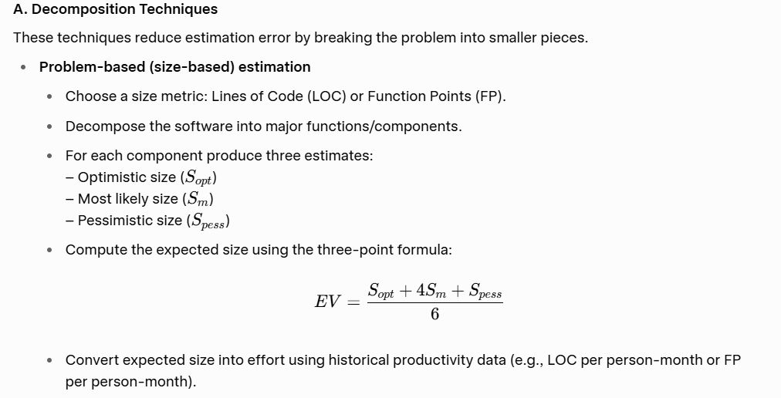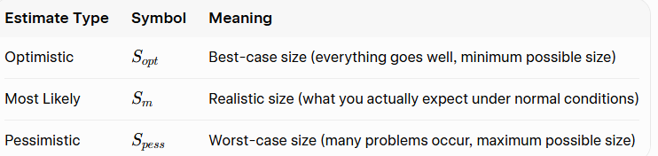

Compute the Expected Size (EV) using the Three-Point Formula

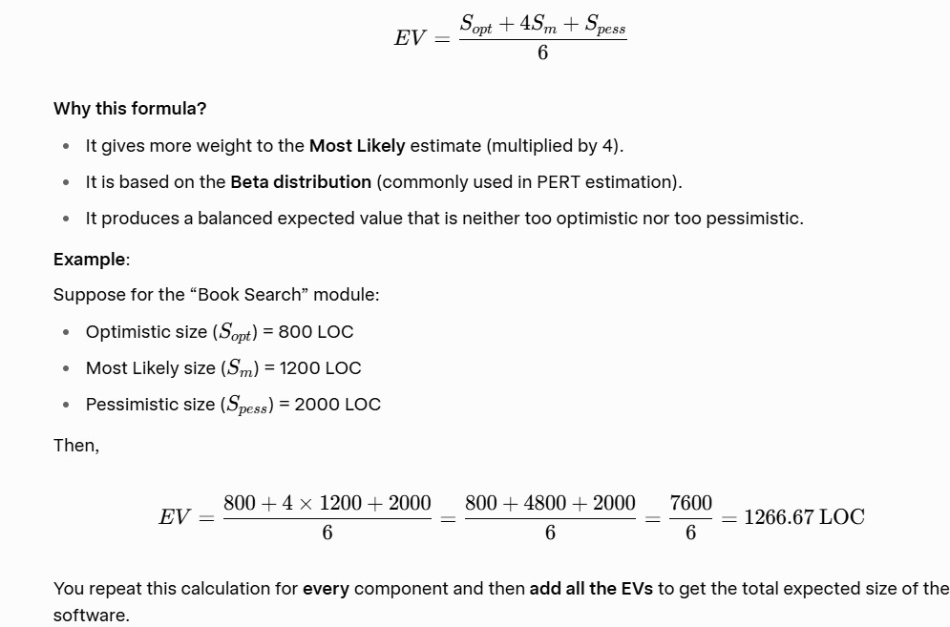

Convert Expected Size into Effort
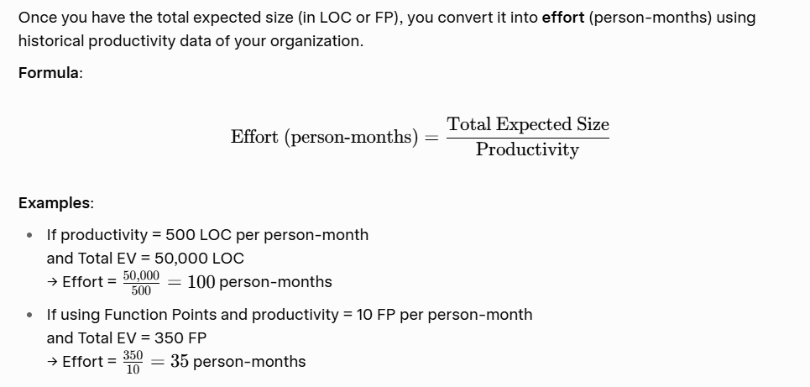

- Process-based estimation Allocate percentages of the total effort to the major process activities (customer communication, planning, risk analysis, engineering, construction, deployment, etc.). The percentages are adjusted according to project type, size, and complexity.

Use-Case Based Estimation (later editions)
Estimate based on the number and complexity of use cases.
Convert use cases into effort using historical productivity data.

B. Empirical / Parametric Models
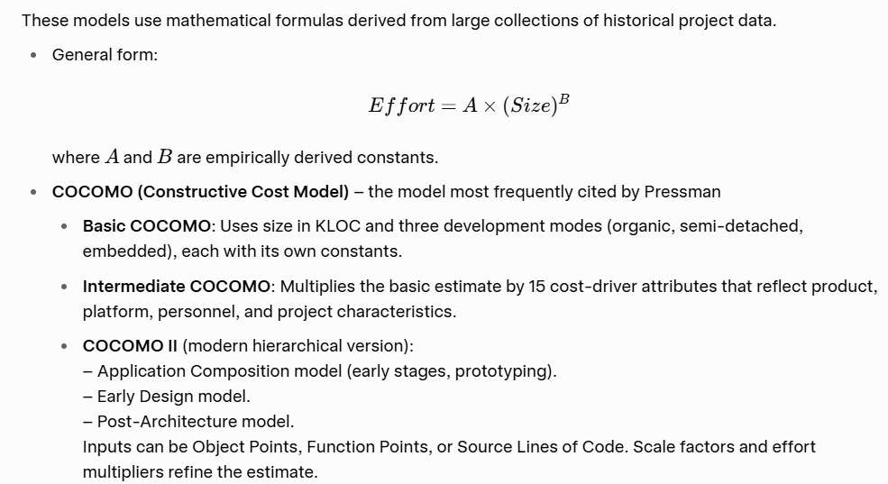
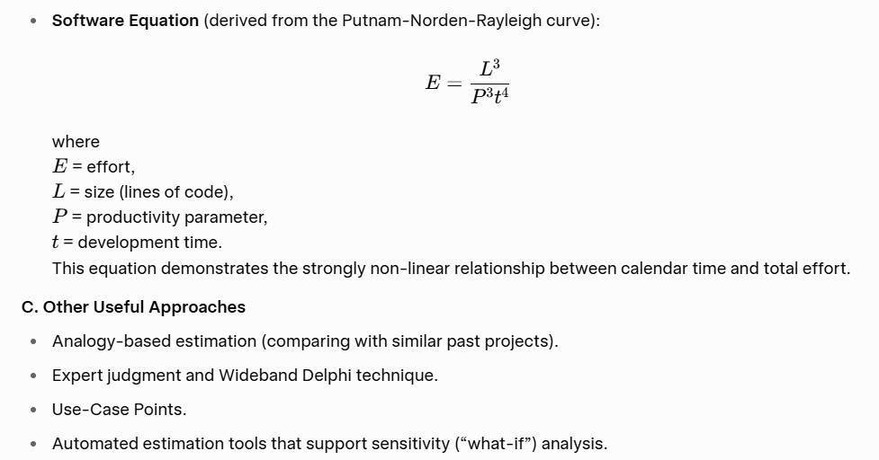
Empirical Models
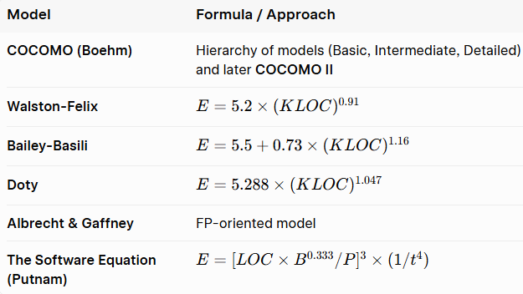

Introduction to COCOMO Model
COCOMO stands for Constructive Cost Model.
It is one of the most popular and widely used software cost estimation models in software engineering.
COCOMO was developed by Dr. Barry W. Boehm in 1981. It helps project managers estimate the effort (in person-months), time (in months), and cost required to develop a software project.

Why is COCOMO Important?
- It provides a systematic and scientific way to estimate software development effort.
- It is based on historical data from real software projects.
- It helps in better project planning, budgeting, and scheduling.

Basic Idea of COCOMO
COCOMO estimates the effort required based mainly on the size of the software.
The size is usually measured in KLOC (Kilo Lines of Code), i.e., thousands of lines of source code.
The basic relationship is:
Effort increases as the size of the software increases.

Three Types of Projects in COCOMO
COCOMO classifies software projects into three categories (modes):
- Organic Mode
  - Small and simple projects
  - Small team with good experience
  - Example: Simple business applications, payroll systems
- Semi-Detached Mode
  - Medium-sized projects
  - Team has mixed experience
  - Example: Database systems, utility software
- Embedded Mode
  - Complex and large projects
  - Strict constraints (real-time, hardware, safety)
  - Example: Air traffic control systems, military software

Levels of COCOMO
COCOMO has three levels of detail:
- Basic COCOMO → Rough estimate using only size
- Intermediate COCOMO → More accurate (uses size + 15 cost drivers)
- Detailed COCOMO → Most accurate (considers different phases of the project)

- COCOMO / COCOMO II (Barry Boehm)

Original COCOMO (COCOMO 81)
It is a hierarchy of three models:
- Basic COCOMO: Uses only size (KLOC) and project mode.
- Intermediate COCOMO: Adds 15 cost drivers (Effort Adjustment Factor – EAF).
- Detailed COCOMO: Applies cost drivers phase-wise.
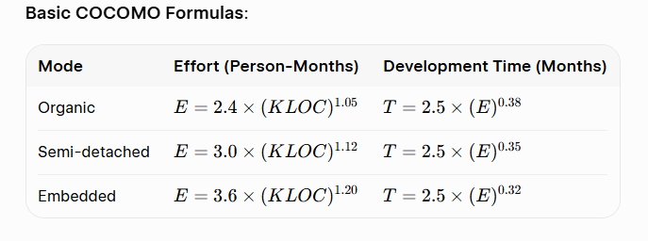
COCOMO II (Modern version)
Highlights COCOMO II as an improvement that supports modern development practices. It has three sub-models:
- Application Composition Model – Early stage, uses Object Points.
- Early Design Model – Uses Function Points or KSLOC + limited cost drivers.
- Post-Architecture Model – Most detailed, uses 17 cost drivers + 5 scale factors.
General form of COCOMO II:
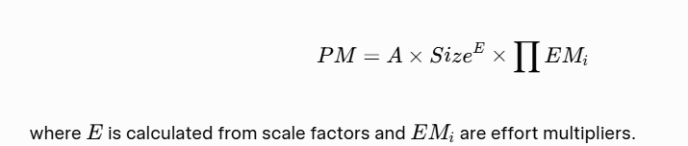
The Software Equation (Putnam Model / SLIM)
Developed by Lawrence H. Putnam. It is a dynamic multivariable model based on the Norden-Rayleigh curve (staffing profile follows a Rayleigh distribution).
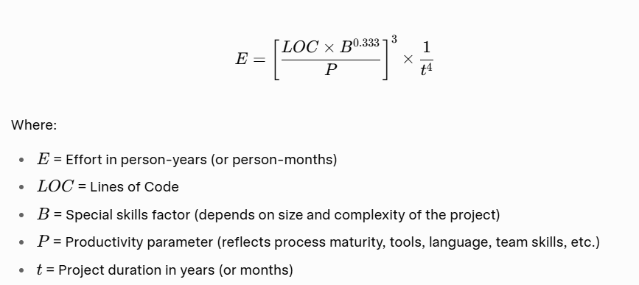

Key Characteristics:
- Highly non-linear relationship between effort and time.
- Extending the schedule can significantly reduce total effort (and vice versa).
- Productivity parameter P is calibrated from historical data of the organization.
- Typical values of P:
  - Real-time embedded → ~2000
  - Systems/telecom → ~10,000
  - Business applications → ~28,000
Simplified forms sometimes used:
- Minimum development time
- Effort in terms of time
This model is the foundation of the commercial SLIM (Software Lifecycle Management) tool.
- Other Regression-Based Models
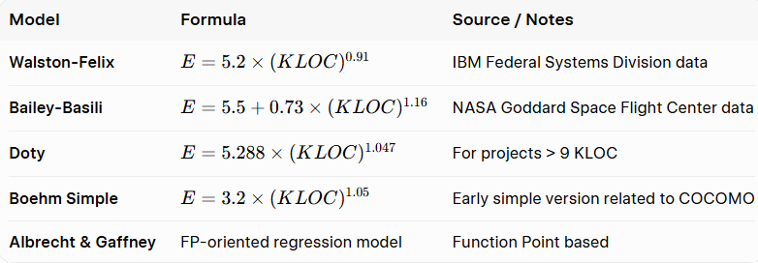

Example 1: Organic Mode
Problem:
A simple business application is estimated to be 40 KLOC.
It is an Organic type project.
Calculate:
- Effort (Person-Months)
- Development Time (Months)
- Average Staff required
Solution:
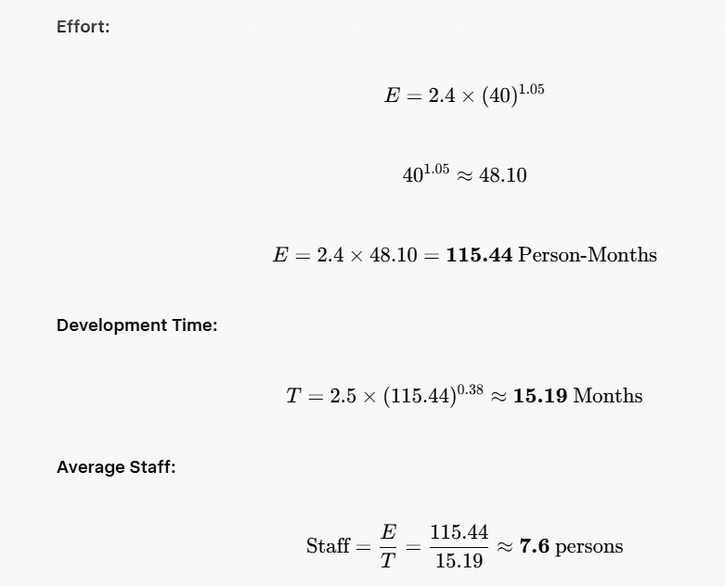

Example 2: Semi-detached Mode
Problem:
A utility software project is estimated at 100 KLOC.
It is a Semi-detached type project.
Calculate Effort, Time and Staff.
Solution:
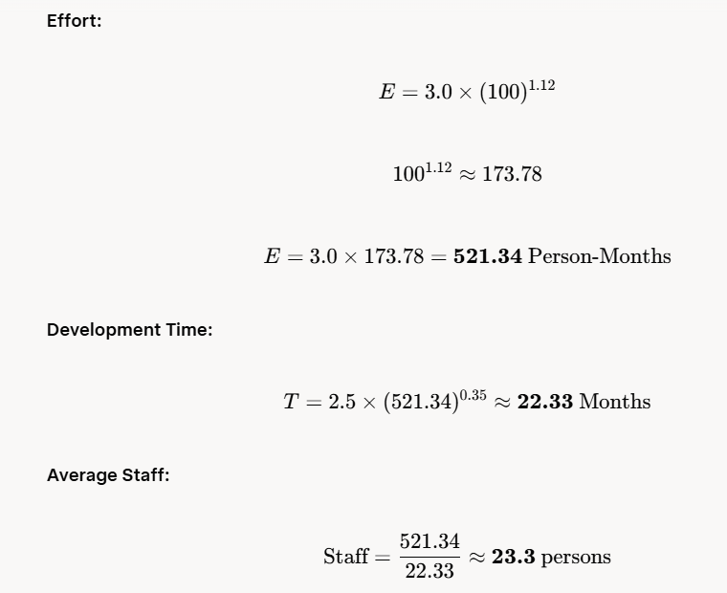

Example 3: Embedded Mode
Problem:
A real-time control system is estimated at 150 KLOC.
It is an Embedded type project.
Calculate Effort, Time and Staff.
Solution:
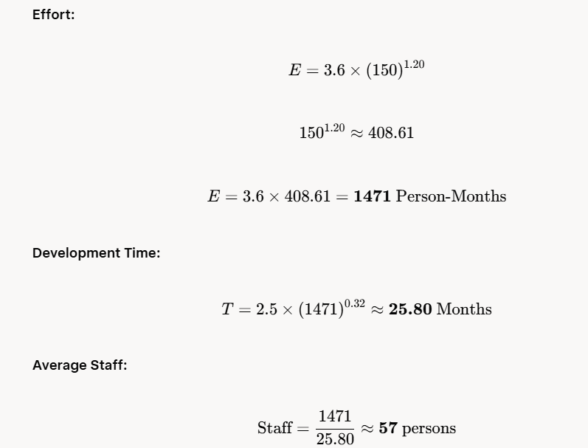
4.
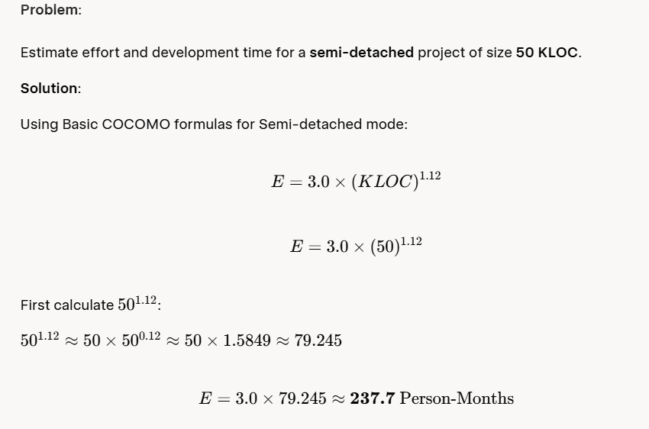

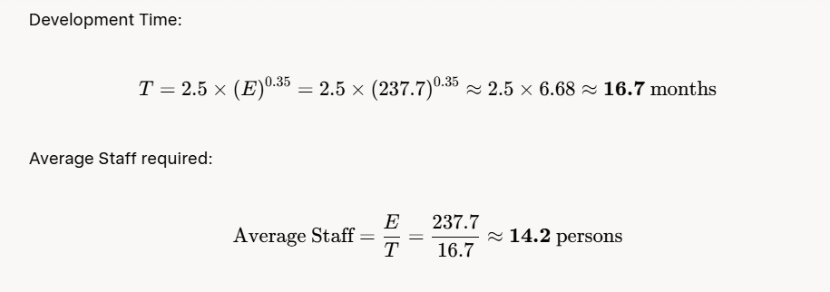

Intermediate COCOMO Example
Problem:
Same project (Semi-detached, 50 KLOC), but now we apply cost drivers.
Assume the following cost driver ratings (typical values):
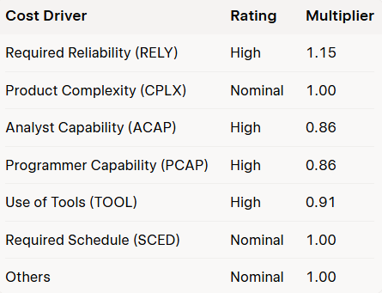

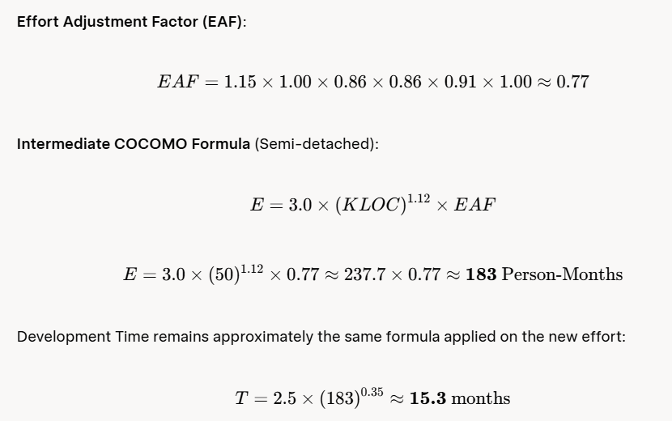

Putnam’s Software Equation Example
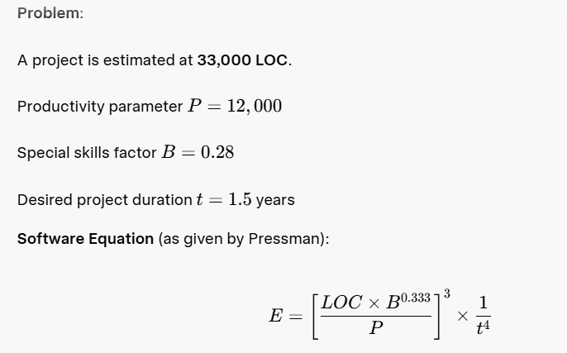
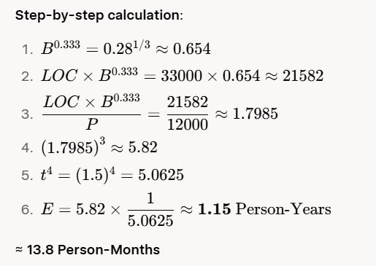

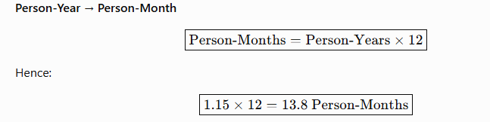

Project Schedule and Staffing
Software project scheduling is the activity that distributes the estimated effort across the planned project duration by allocating that effort to specific software engineering tasks.
Fundamental Scheduling Principles
- Compartmentalization – Define distinct, manageable tasks.
- Interdependency – Identify which tasks must be sequential and which can be performed in parallel.
- Time allocation – Assign realistic start dates, end dates, and effort to every task.
- Effort validation – Ensure that the total effort assigned equals the estimated effort and that no individual is over-allocated.
- Defined responsibilities – Every task has a clearly named owner.
- Defined outcomes – Every task produces a concrete work product.
- Defined milestones – Establish review points at which progress and quality are formally assessed.

Relationship Between People and Effort
The relationship is highly non-linear (illustrated by the Putnam-Norden-Rayleigh / PNR curve).
- There exists a minimum development time below which the project cannot be completed no matter how many people are added.
- Adding people late in a project almost always delays it further (the classic Brooks’s Law effect).
- The Software Equation quantifies this non-linearity and shows that aggressive schedule compression dramatically increases total effort (and therefore cost).

Classic Effort Distribution – the 40-20-40 Rule
A widely used guideline (to be adjusted for each project):
- ≈ 40 % of total effort → front-end activities (customer communication, requirements analysis, design, reviews).
- ≈ 20 % of total effort → construction (coding / code generation).
- ≈ 40 % of total effort → back-end activities (testing, debugging, deployment, support).
Project planning itself usually consumes only 2–3 % of total effort. Safety-critical or highly novel systems typically require more analysis and testing effort.

How to Build the Schedule
- Select or tailor a task set appropriate to the project type and required degree of rigor.
- Refine the major tasks into a detailed work-breakdown structure.
- Construct a task network (activity network / PERT-style diagram) that shows dependencies.
- Produce a timeline chart (Gantt chart) that includes milestones.
- Perform resource leveling so that people are not over-allocated.
- Track progress continuously (earned-value analysis is strongly recommended) and re-plan whenever reality diverges from the plan.

Staffing Considerations
- Average staff size ≈ Total estimated person-months ÷ Planned project duration in months.
- Staffing profiles (loading curves) show how the demand for different roles (requirements engineers, architects, designers, programmers, testers, etc.) varies over the life of the project.
- Use a human-resources matrix or resource-Gantt chart to allocate named individuals without creating bottlenecks.
A simple Gantt chart can look like this:
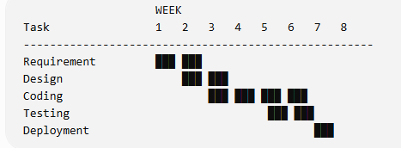
- Account for ramp-up time, skill mix, training needs, and communication overhead (which grows roughly with the square of team size).

Quality Planning
Definition of Software Quality Conformance to:
- Explicitly stated functional and performance requirements,
- Explicitly documented development standards, and
- Implicit characteristics that are expected of all professionally developed software.
Core Principle Quality cannot be “inspected into” a product at the end. It must be planned and built in from the beginning. Therefore quality planning is an integral part of the overall project plan.

The Software Quality Assurance (SQA) Plan
The SQA Plan (often prepared or reviewed by an independent SQA group) typically contains:
- Purpose, scope, and measurable quality goals.
- Organizational structure and responsibilities (especially the role and independence of the SQA group).
- Applicable standards, procedures, guidelines, and conventions.
- Planned reviews and audits (formal technical reviews, inspections, walkthroughs, management reviews).
- Testing strategy and major test activities.
- Defect reporting, tracking, and analysis procedures.
- Configuration management and change-control interfaces.
- Tools, methods, and training requirements.
- Schedule of all quality-related activities.
- Metrics to be collected and reporting mechanisms.
- Procedures for handling non-conformance and escalation.

SQA Activities
- Application of rigorous technical methods and good engineering practice.
- Formal technical reviews (FTRs) at every major work product.
- A multi-level testing strategy (unit, integration, validation, system, acceptance).
- Enforcement of standards.
- Measurement and collection of quality metrics (defect density, review effectiveness, test coverage, etc.).
- Change management.
- Systematic record-keeping and reporting to project and senior management.

Cost of Quality
distinguishes four categories:
- Prevention costs – training, process definition, tools, methodology.
- Appraisal costs – reviews, inspections, testing.
- Internal failure costs – rework discovered before delivery.
- External failure costs – defects found by customers, warranty work, reputation damage.
Experience shows that investment in prevention and early appraisal almost always reduces the total cost of quality.
Quality activities consume a substantial fraction of total project effort; therefore they must be explicitly estimated, scheduled, and staffed.

4. Risk Management
A risk is a potential problem — it may or may not occur. Risk management is a systematic series of steps that help a software team understand and manage uncertainty so that problems can be avoided or their impact minimized.
Reactive vs. Proactive Strategies
- Reactive: Wait until the risk materializes and then try to recover (fire-fighting).
- Proactive (strongly recommended): Identify risks early, assess them, and prepare mitigation and contingency plans before they occur.

Categories of Software Risks
- Project risks – schedule slippage, budget overrun, resource shortages, staffing problems, requirements volatility.
- Technical risks – design flaws, implementation difficulties, interface problems, verification challenges, technology immaturity, maintenance difficulties.
- Business risks – building a product no one wants, loss of management or customer support, budget or personnel cuts, poor strategic alignment.
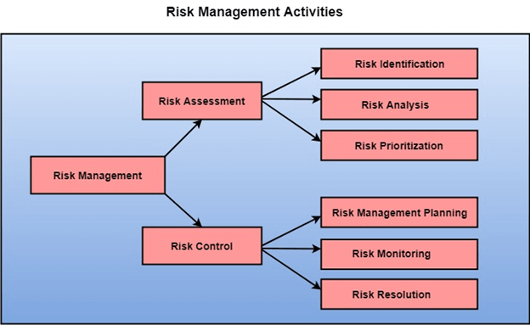

1. Risk Assessment
This is the first major phase. It focuses on understanding and evaluating the risks.
It consists of three activities:
- Risk Identification
Finding out all possible risks that may affect the project (using checklists, brainstorming, historical data, etc.).
- Risk Analysis
Studying each identified risk in detail — estimating its probability of occurrence and its impact/severity.
- Risk Prioritization
Ranking the risks according to their importance (usually based on Risk Exposure = Probability × Impact). High-priority risks get more attention.

2. Risk Control
This is the second major phase. It focuses on taking action on the risks.
It consists of three activities:
- Risk Management Planning
Preparing plans to deal with the risks (mitigation plans and contingency plans).
- Risk Monitoring
Continuously tracking the risks throughout the project to see if their status is changing.
- Risk Resolution
Actually implementing the plans when a risk occurs or when action is needed to reduce it (also called risk mitigation or handling).

The Risk Management Process

Step 1: Risk Identification
A systematic attempt to identify all possible threats to the project plan.
Techniques used:
- Risk item checklists
- Brainstorming sessions
- Review of project plan, requirements, and technical environment
- Lessons learned from previous projects
Risks are generally classified as:
- Project risks
- Technical risks
- Business risks

Step 2: Risk Projection (also called Risk Estimation)
For every identified risk, two important values are estimated:
- Probability of occurrence (p)
- Impact / consequence (x)

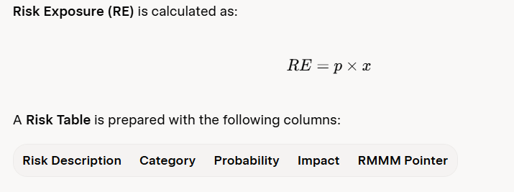

The table is sorted according to probability and impact. High-risk items (high probability or high impact) are given higher priority.

Step 3: Risk Refinement
High-priority risks are refined into more detailed and specific risk statements. This helps in understanding exactly when, why, and how the risk might occur.

Step 4: Risk Mitigation, Monitoring and Management (RMMM)
- Mitigation: Actions taken in advance to reduce either the probability or the impact of the risk.
- Monitoring: Continuously tracking risk indicators and checking whether mitigation steps are being followed.
- Management: Pre-defined contingency plans that will be executed if the risk actually materializes.
All these activities are documented in an RMMM Plan.

Estimation for Software Projects
What is Estimation?
Estimation means predicting the resources (people), cost, and schedule required to complete the software project.
Pressman states that successful estimation requires three things:
- Experience of the estimator
- Access to good historical data (metrics from previous projects)
- The courage to make quantitative predictions even when complete information is not available
Classification of Estimation Techniques
It divides estimation techniques into two broad categories:
- Decomposition Techniques
- Empirical Estimation Models (e.g., COCOMO)

Decomposition Techniques
Decomposition techniques follow the principle of “divide and conquer”.
The large problem of estimating the whole project is broken into smaller, manageable parts.
Pressman classifies decomposition techniques into two types:

A. Problem-Based Estimation
The software is decomposed according to the problem functions (features) that the software must deliver to the user.

B. Process-Based Estimation
The software is decomposed according to the software engineering activities (also called framework activities) such as:
- Communication
- Planning
- Modeling
- Construction
- Deployment

4. Software Sizing
Before we can estimate effort or cost, we must first estimate the size of the software to be built.

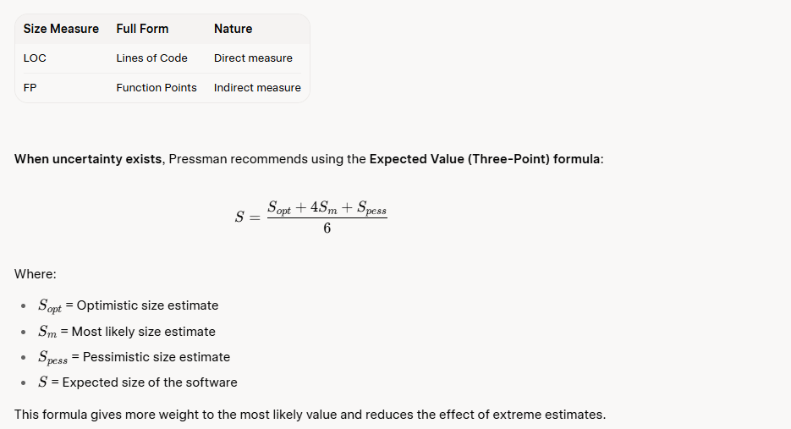

Problem-Based Estimation
Problem-based estimation is one of the most important decomposition techniques.
Steps given by Pressman:
- Start with a bounded statement of software scope
Clearly define what the software will do and what it will not do.
- Decompose the software into problem functions
Break the overall software into major functional components (modules/features).
- Estimate size (LOC or FP) for each function
For each function, calculate either Lines of Code or Function Points (preferably using the three-point expected value method).
- Apply baseline productivity metrics
Use historical data of the organization such as:
  - LOC per person-month, or
  - Function Points per person-month
- Combine the individual estimates
Add the effort/cost of all functions to get the overall project estimate.

Complete Practical Example
Project: Development of a College Management System
Risk Identified:
The senior database designer may leave the company in the middle of the project.

Risk Assessment
- Identification: Senior DB designer may resign
- Analysis:
  - Probability = 35%
  - Impact = Very High (project can get delayed by 2–3 months)
- Prioritization: High priority risk

Risk Control
- Planning:
  - Give knowledge transfer sessions
  - Prepare detailed database documentation
  - Train one junior developer as backup
- Monitoring:
  - Project manager talks to the designer every two weeks
  - Checks his job satisfaction level
- Resolution:
  - If the designer resigns, the trained junior developer takes over immediately using the documentation

